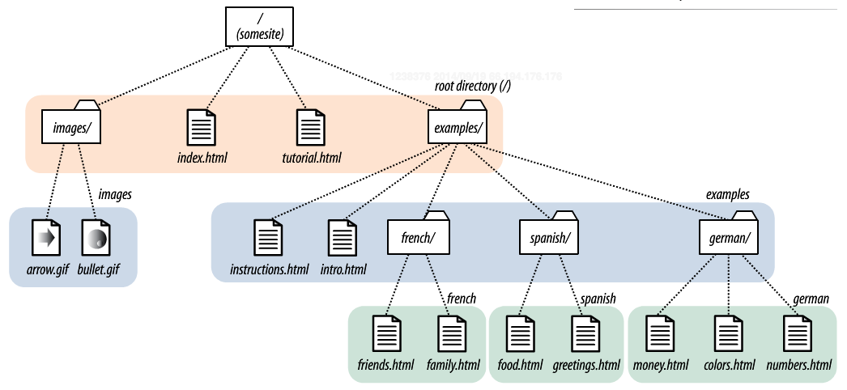

<!DOCTYPE html>

<html>

<head>

<meta charset="utf-8">

<title>Home page</title>

</head>

<body bgcolor="#FFFFFF">

<nav>

<h3>Internal Links inside my document</h3>

<ol>

<li>put a link to the conclusion here, you may have to do something else first</li>

<li>put a link to the results here, you may have to do something else first, you may have to do something else first</li>

</ol>

<h3>External Links on my Server</h3>

<ol>

<li>put a link to the instructions here</li>

<li>put a link to the tutorial here</li>

</ol>

<h3>External Links on different Server (absolute hyperlinks)</h3>

<ol>

<li>put a link to Facebook here</li>

<li>put a link to the site for Web Pages That Suck</li>

</ol>

</nav>

Insert the arrow image here

<p>This is going to be a long sentence. This is going to be a long sentence.This is going to be a long sentence.This is going to be a long sentence.This is going to be a long sentence.This is going to be a long sentence.This is going to be a long sentence.This is going to be a long sentence.This is going to be a long sentence. </p>

<p>This is going to be a long sentence. This is going to be a long sentence.This is going to be a long sentence.This is going to be a long sentence.This is going to be a long sentence.This is going to be a long sentence.This is going to be a long sentence.This is going to be a long sentence.This is going to be a long sentence.This is going to be a long sentence.This is going to be a long sentence.This is going to be a long sentence.This is going to be a long sentence. </p>

<h2>Results</h2>

<p>This is going to be a long sentence. This is going to be a long sentence.This is going to be a long sentence.This is going to be a long sentence.This is going to be a long sentence.This is going to be a long sentence.This is going to be a long sentence.This is going to be a long sentence.This is going to be a long sentence.This is going to be a long sentence.This is going to be a long sentence.This is going to be a long sentence.This is going to be a long sentence.This is going to be a long sentence.This is going to be a long sentence. This is going to be a long sentence.</p>

<p>This is going to be a long sentence. This is going to be a long sentence.This is going to be a long sentence.This is going to be a long sentence.This is going to be a long sentence.This is going to be a long sentence.This is going to be a long sentence.This is going to be a long sentence. </p>

<h2>Conclusion</h2>

<p>This is going to be a long sentence. This is going to be a long sentence.This is going to be a long sentence.This is going to be a long sentence.This is going to be a long sentence.This is going to be a long sentence.This is going to be a long sentence.This is going to be a long sentence.This is going to be a long sentence.This is going to be a long sentence.This is going to be a long sentence.This is going to be a long sentence.This is going to be a long sentence.This is going to be a long sentence.This is going to be a long sentence.This is going to be a long sentence.This is going to be a long sentence.This is going to be a long sentence.This is going to be a long sentence.This is going to be a long sentence.This is going to be a long sentence.This is going to be a long sentence.This is going to be a long sentence.</p>

<p>This is going to be a long sentence. This is going to be a long sentence.This is going to be a long sentence.This is going to be a long sentence.This is going to be a long sentence.This is going to be a long sentence.This is going to be a long sentence.This is going to be a long sentence.This is going to be a long sentence.This is going to be a long sentence.This is going to be a long sentence.This is going to be a long sentence.This is going to be a long sentence.This is going to be a long sentence.This is going to be a long sentence.This is going to be a long sentence.This is going to be a long sentence.This is going to be a long sentence.This is going to be a long sentence.This is going to be a long sentence.This is going to be a long sentence.This is going to be a long sentence.This is going to be a long sentence.</p>

</body>

</html>